**INTI International College Penang School of Engineering and Technology**

**3+0 Bachelor of Science (Hons) in Computer Science, in collaboration with Coventry University, UK**

**3+0 Bachelor of Science (Hons) in Computing, in collaboration with Coventry University, UK**

**Coursework cover sheet**

**Section A - To be completed by the student**

| Full Name:Ota Kazuki | |
| --- | --- |
| CU Student ID Number:p20012061 | |
| Semester:  **3** | |
| Session:  **April 2022** | |
| Lecturer:  **Nadhrah Abdul Hadi (nadhrah.abdulhadi@newinti.edu.my)** | |
| Module Code and Title:  **4067CEM Software Design** | |
| Assignment No. / Title:  **Continuous Assessment** | % of Module Mark:  **50** |
| Hand out Date:  **22nd April 2022** | Due Date:  **Task 1: 13 May 2022, by 11.59pm**  **Task 2: 1 July 2022, by 11.59pm**  **Task 3: 17 June 2022, by 11.59pm.**  **Task 4: 17 June 2022, by 11.59pm.**  **Task 5: 17 June 2022, by 11.59pm.** |
| Penalties: No late work will be accepted. If you are unable to submit coursework on time due to extenuating circumstances, you may be eligible for an extension. Please consult the lecturer. | |
| Declaration: I/we the undersigned confirm that I/we have read and agree to abide by the University regulations on plagiarism and cheating and Faculty coursework policies and procedures. I/we confirm that this piece of work is my/our own. I/we consent to appropriate storage of our work for plagiarism checking.  Signature(s): ________________________ | |

**Section B - To be completed by the module leader**

| Intended learning outcomes assessed by this work:  1. Understand and apply appropriate concepts, tools and techniques to each stage of the software development  2. Understand and apply design patterns to software components in developing new software  3. Demonstrate an understanding of project planning and working to agreed deadlines, along with professional, interpersonal skills and effective communication required for software production  5. Demonstrate an awareness of, and ability to apply, social, professional, legal and ethical standards as documented in relevant laws and professional codes of conduct such as that of the Malaysian National Computer Confederation. | | |
| --- | --- | --- |
| Marking scheme | Max | Mark |
| 1. User Story Mapping 2. Setting up a GitHub Repository 3. Creating a Class diagram and design pattern selection 4. Creating a Prototype User Interface and Usability Testing 5. Discuss the ethical issue related to the software | 20  10  30  20  20 |  |
| Total | 100 |  |

**The 4067CEM assessment should be completed as a full individual work over the course of the module. The assessment output are only judged at the end of the module and not by the expectations during that week. The assessment should be undertaken individually. All submissions will be checked against each other and the internet for possible plagiarism.**

Activities – These activities consists of **50%** of your coursework marks. It will be run throughout the semester and there will be a final submission at the end of the semester. These activities consists of activities that will be done in a software design phase.

Usability Test Question

Important feature in system

Test In The Event Page

1:What are you thinking as you view the Event Page ?

2:If you are looking for Event Details, where do you expect to find it ?

3:If you want to see more events, where do you expect to find them?

4:If you want to see more past events, what do you do to find them?

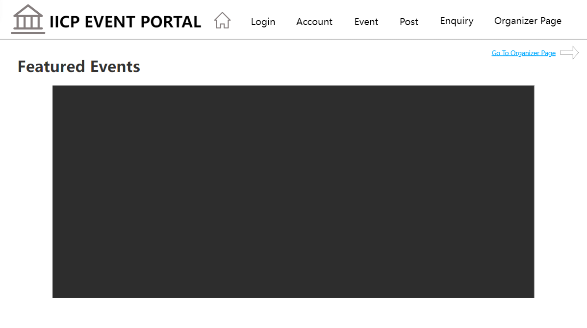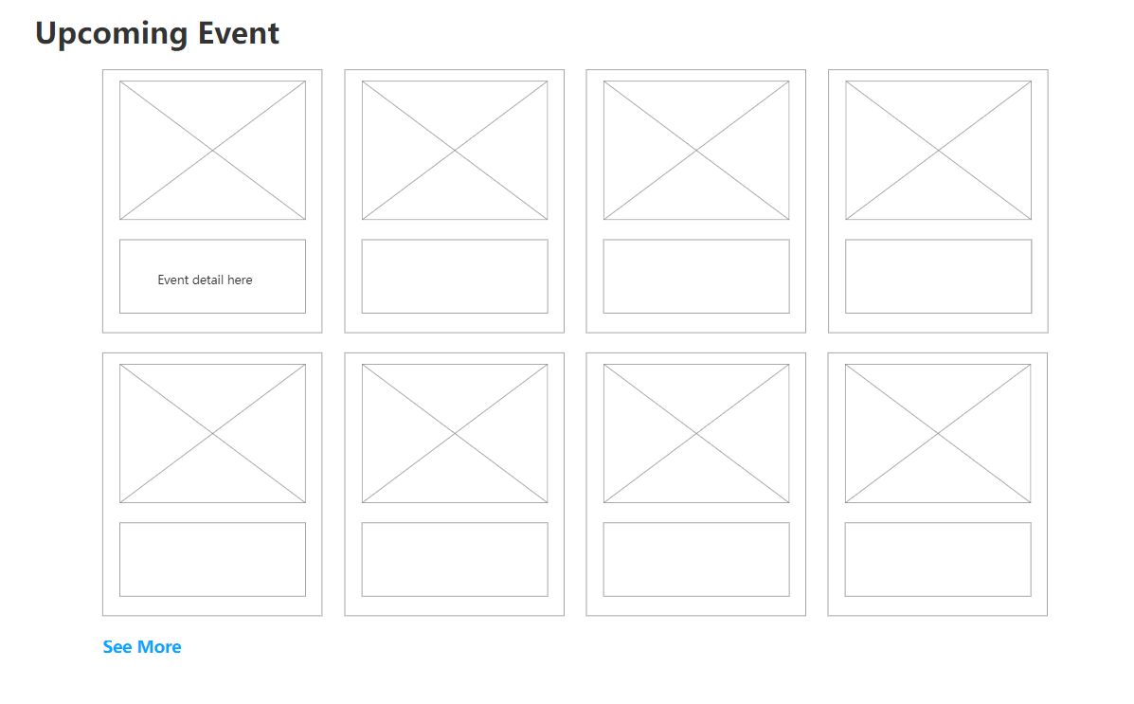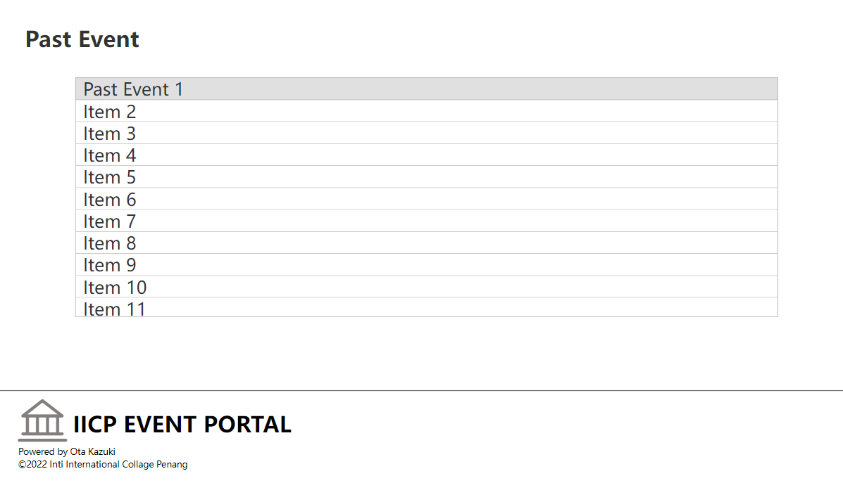

Test in Event details Page

1:If you want to contact the organizer, what would you expect to do?

2:If you want to view the venue map , what would you expect to do?

3:If you want to join an event, what would you expect to do?

4:To submit an online register form, what would you expect to do?

5:If you want to cancel your registration, what would you expect to do?

6:If you want to go back to the previous page ,what would you expect to do ?

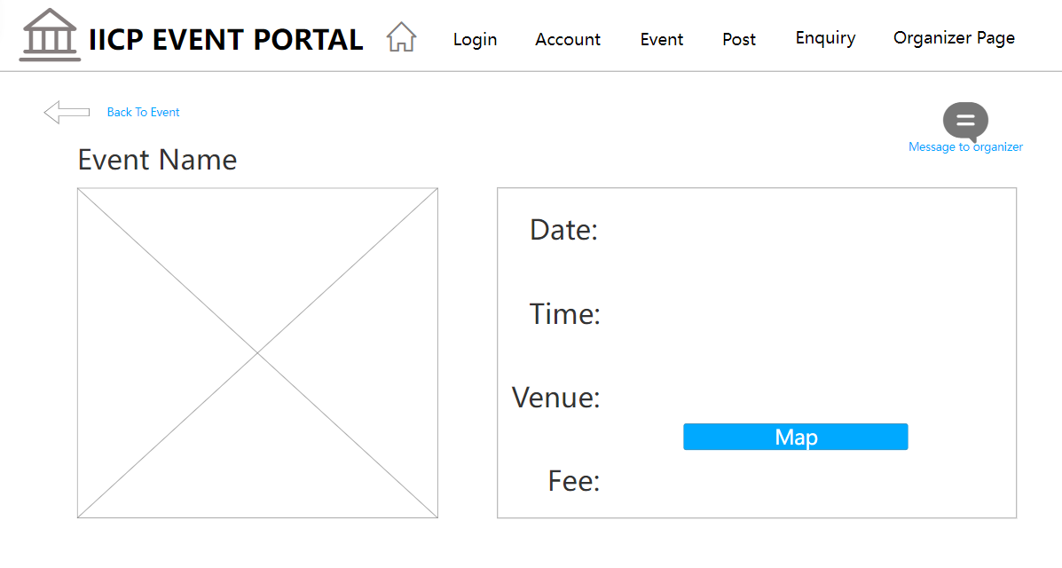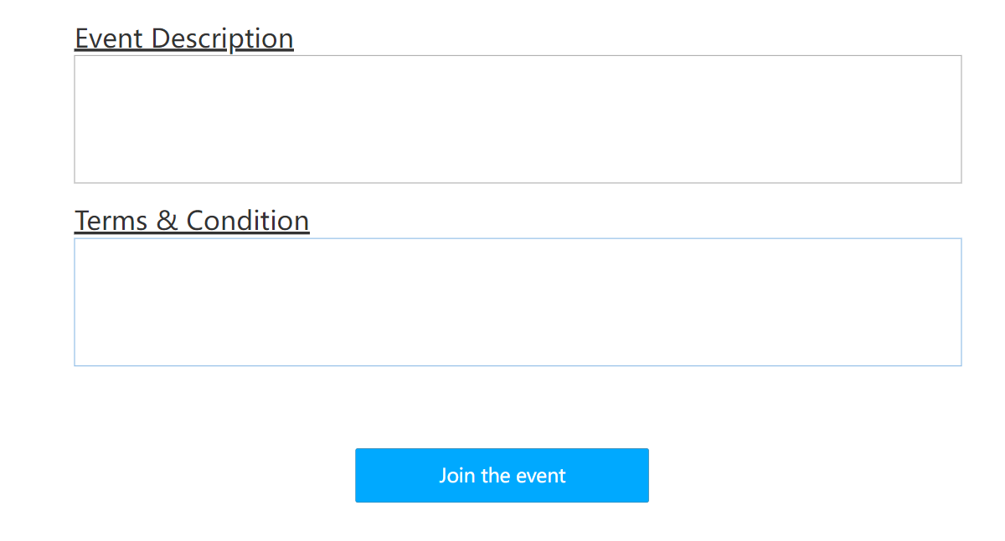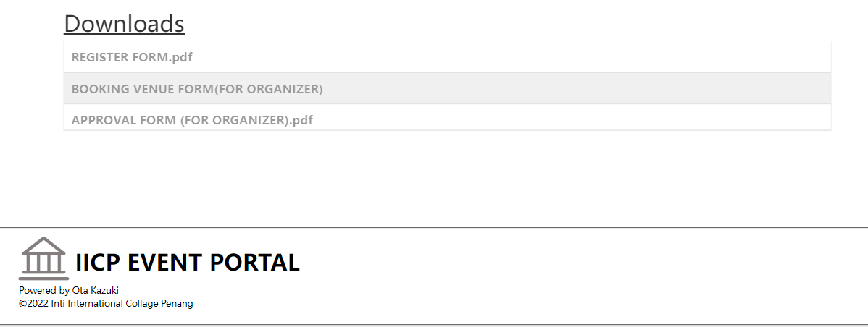

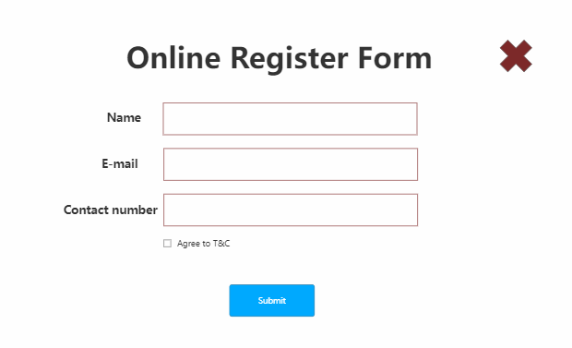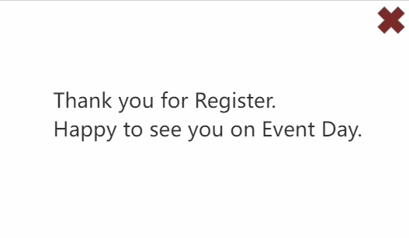

Test for Organize new Event page

1:If you want to add event details, what would you do?

2:If you want to confirm the information, what would you do?

3:If you want to upload an image of a map , what would you do?

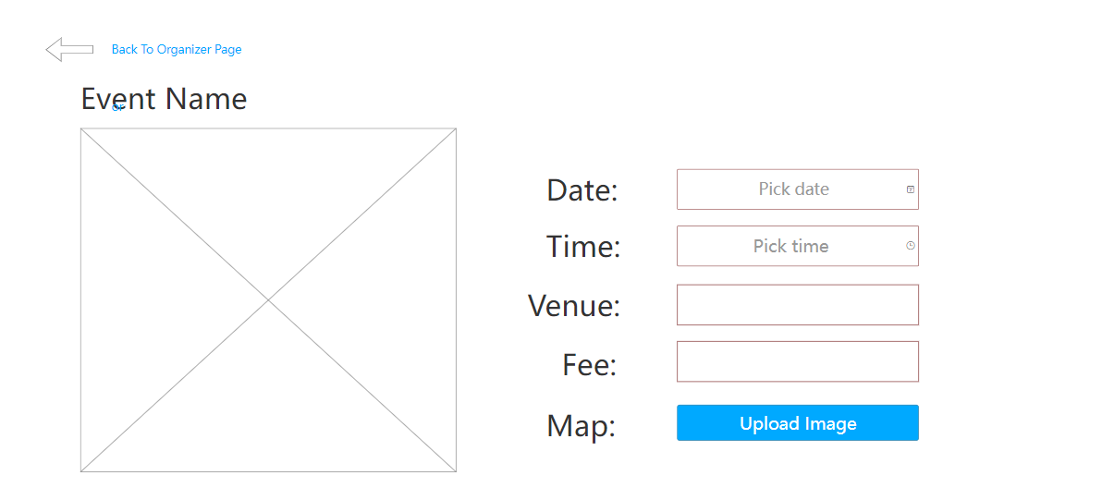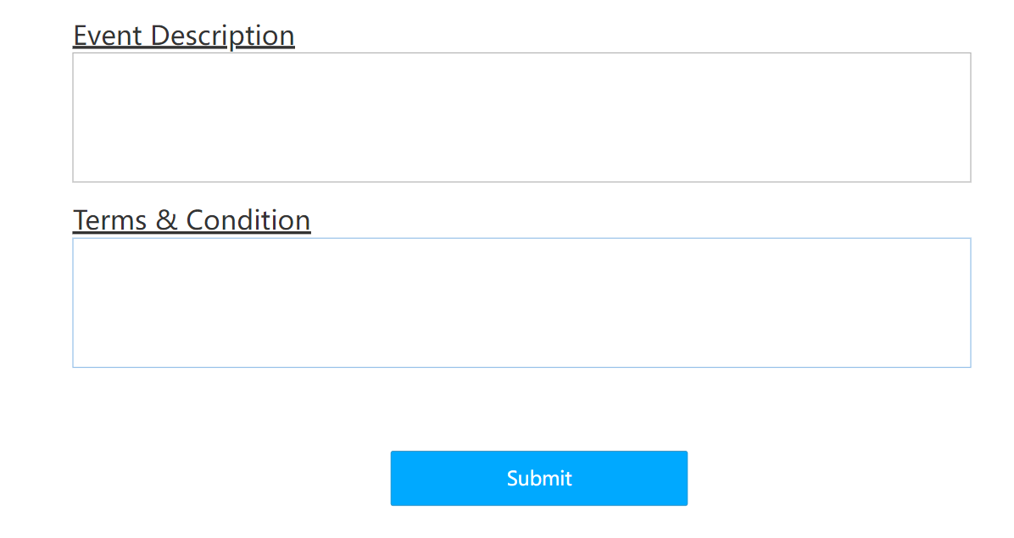

Link To The Prototype:<https://app.mockplus.com/s/U9OWpEDRKoh>

